**TYPE OF DOCUMENT**

**v0.X**

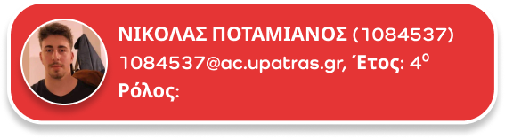

**1084537@ac.upatras.gr,**

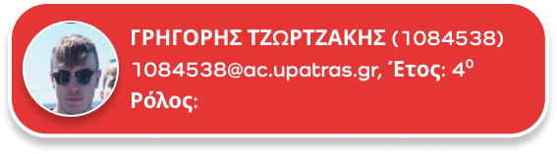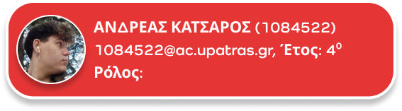

**Ρόλος**

**Ρόλος**

**Ρόλος**

**Ρόλος**

**1084522@ac.upatras.gr,**

**1084541@ac.upatras.gr,**

**1084538@ac.upatras.gr,**